DAY 21: Mythic Agent Setup
Summary: Today, I will play the role of an attacker though performing brute force attack to the Windows Server machine using hydra from Kali Linux , and then discover misconfiguration on compromised Windows. I also create an Apollo payload, download it from compromised machine and install that Mythic Agent on that machine.

I will change the password of windows server 2022 to the weak password, which we can guess through several big wordlists:
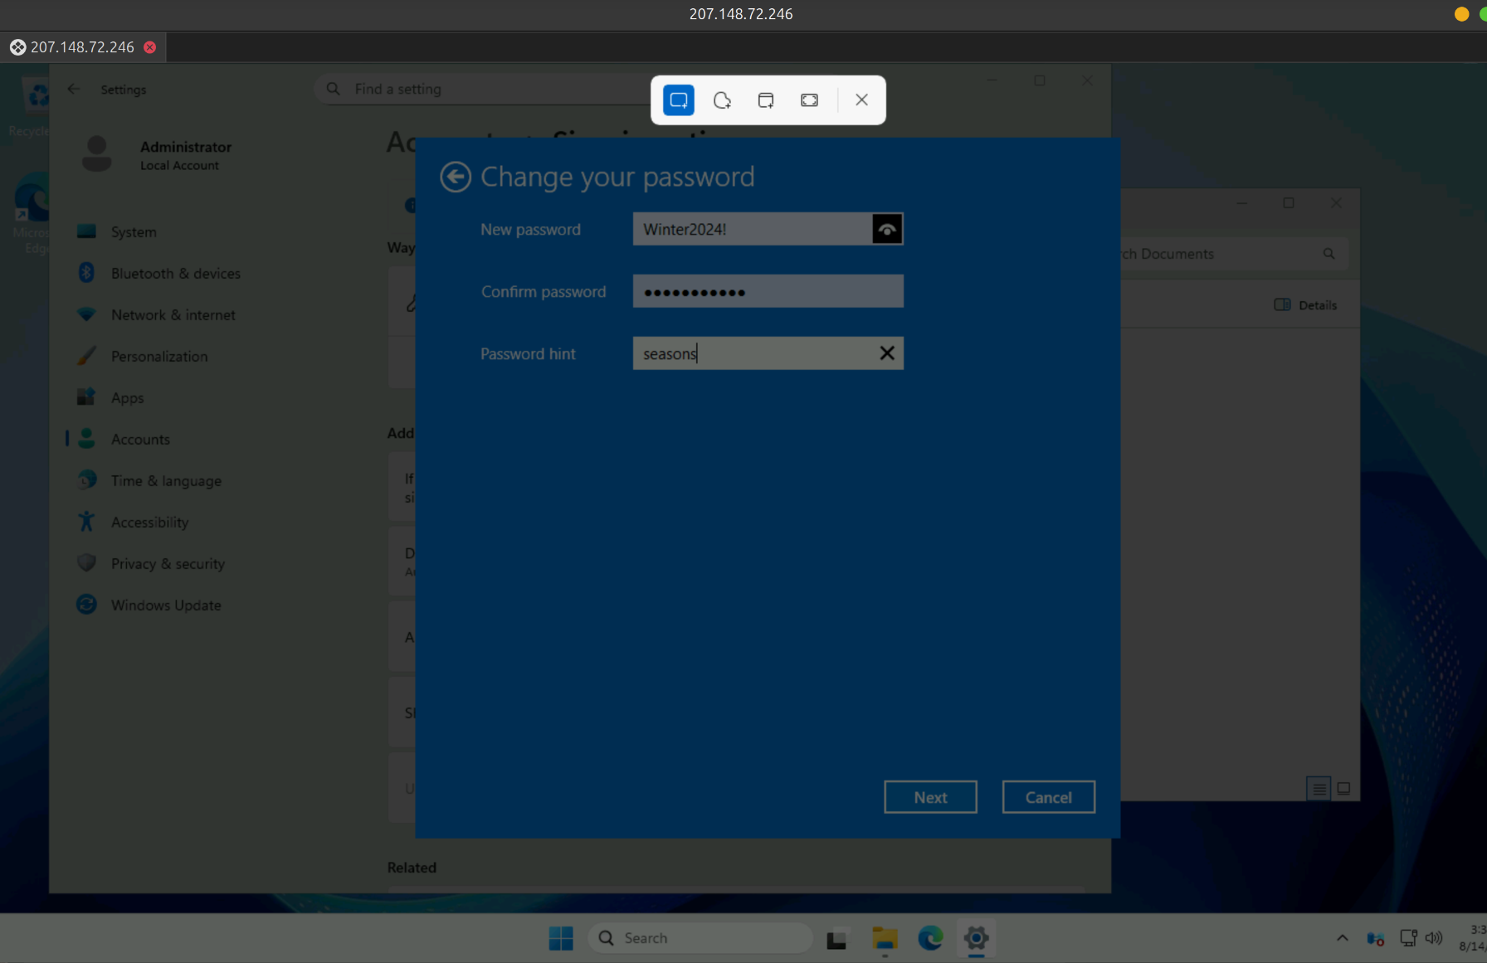
Note: Remember to modify the Group Policy to make changing account passwords more relaxed!!

The wordlist I’m going to use on Kali Linux:
I extracted a portion of the rockyou wordlist in Kali Linux machine, and added some custom passwords to create my own wordlist file, which I named mydfir-wordlist.txt.

Originally, I intended to use crowbar tool. But the tool is using xfreerdp with older version compare my Kali Linux use, I also find ways to repair it, such as edit the code and switch to the older version that match crowbar I’m using, but it’s still not working [1].
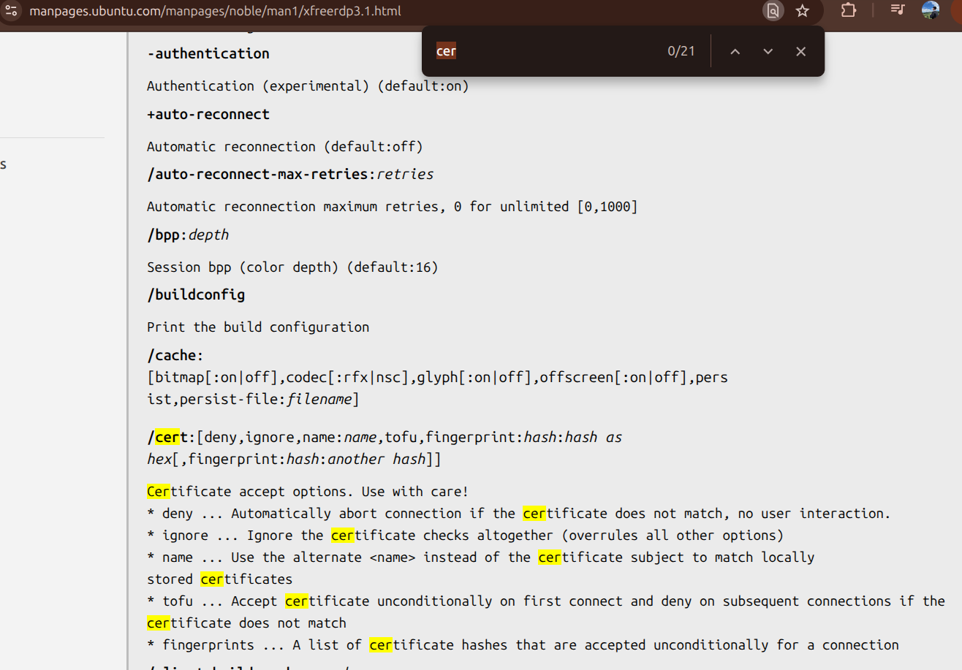
Figure 1: Syntax of xfreerdp3

So, I decided to use other tool called Hydra, this tool is also very common for simulating brute force attacks. Now, I will perform dictionary brute force with my own wordlist, and target user name is Administrator:
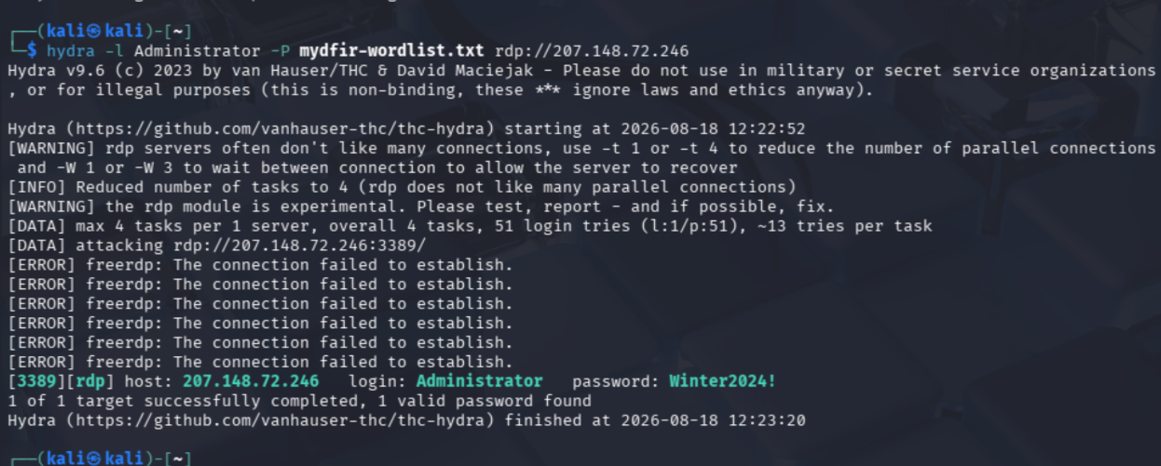
Figure 2: Perform brute force using hydra
Now, you can see in Figure 2, Hydra successfully found Administrator credential in the last line with green color. I will use the password that is found to login that Windows machine using built-in tool xfreerdp as a RDP-client to connect:
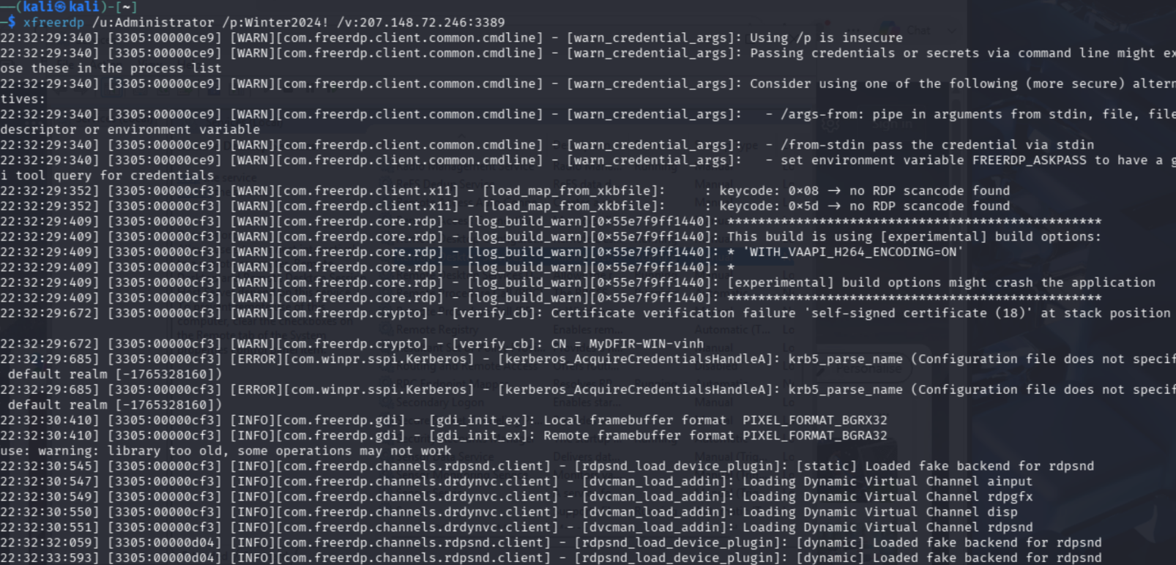
Figure 3: Connect to Windows Server with credential just found

I connected to the machine and next step, I will explore sensitive documents on the machine and the victim network as well.
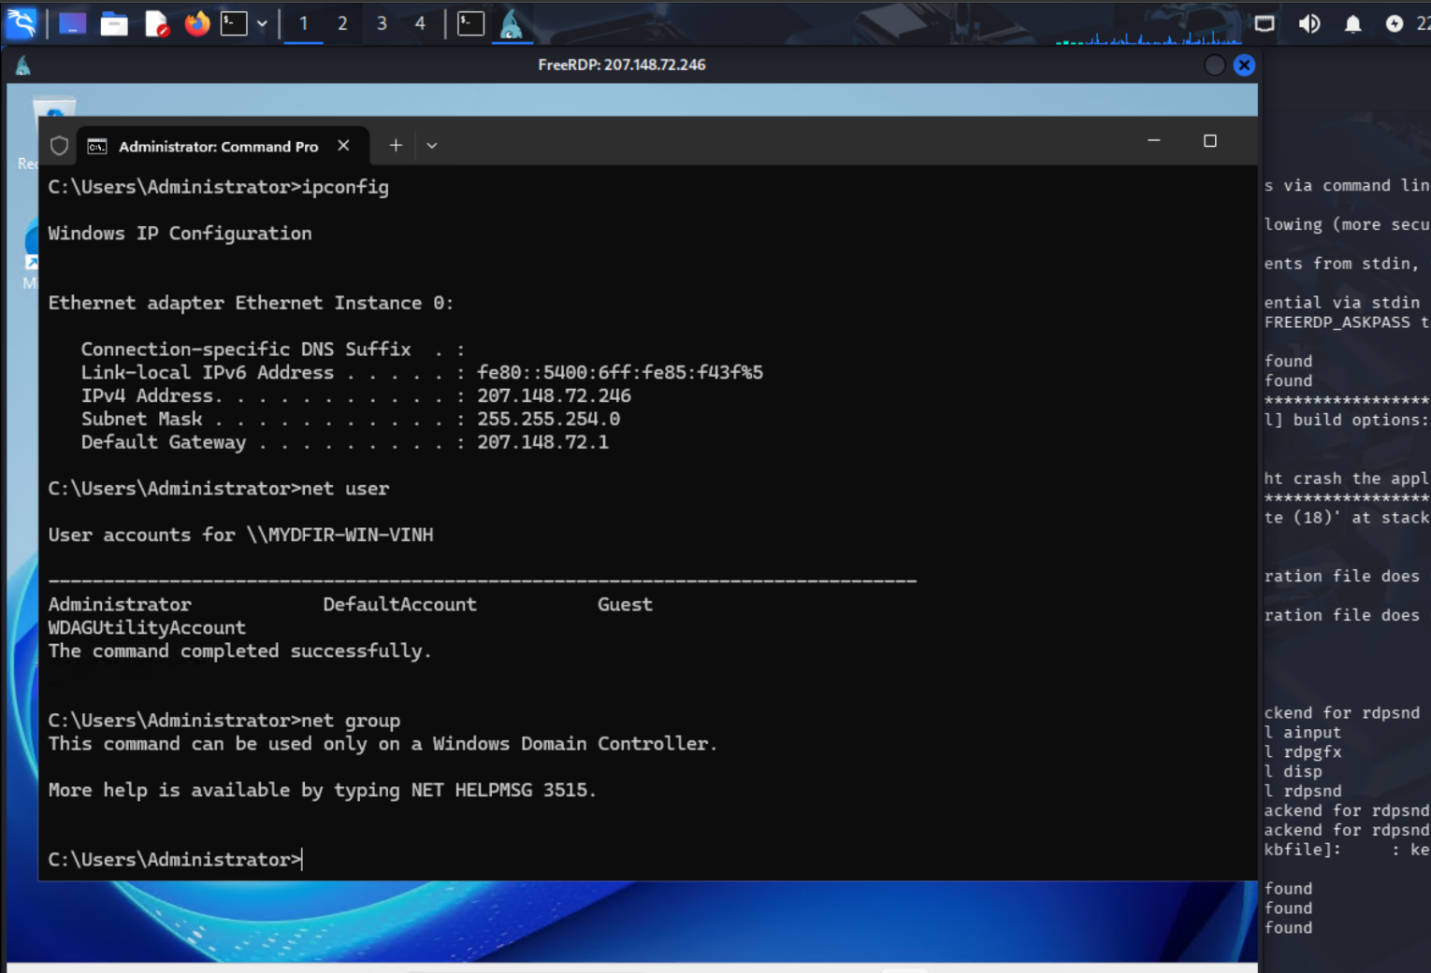
Figure 4: Discover the compromised Windows
As shown in Figure 4, attacker obtained some information such as subnet of the victim belongings to, local user accounts list, include Administrator (current account), DefaultAccount, Guest and WDAGUtilityAccount (a system account used by Windows Defender Application Guard), and net group to display global groups on the network, but in this case displayed an error because server is operating as a standalone machine and isn’t managing an Active Directory domain.
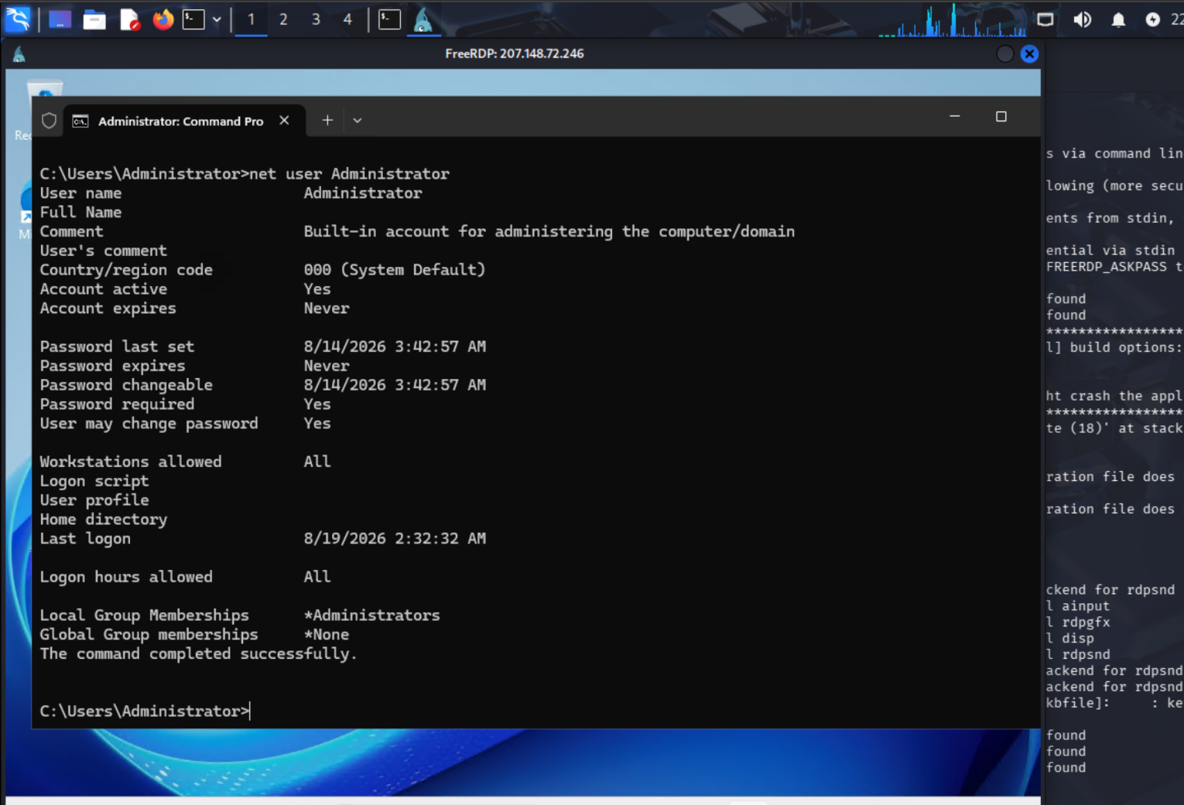
Figure 5: Administrator account properties
Attacker show more detail properties of the Administrator account via “net user Administrator”, this command displayed to console several important information:
- Account status: The output confirms this is the built-in account used for administering the computer, and it is currently active with no set expiration date.
- Activity Logging
- Group Memberships: At the bottom of the output, it shows the account belongs to the local *Administrators group (granting it full system privileges) but has *None for Global Group memberships, further confirming this is a local account on a standalone machine rather than a domain account.

Next step, I will choose the type of agent that is installed on the Windows machine. Go to Agent Matrix site [2] to learn about which is suitable in my situation:
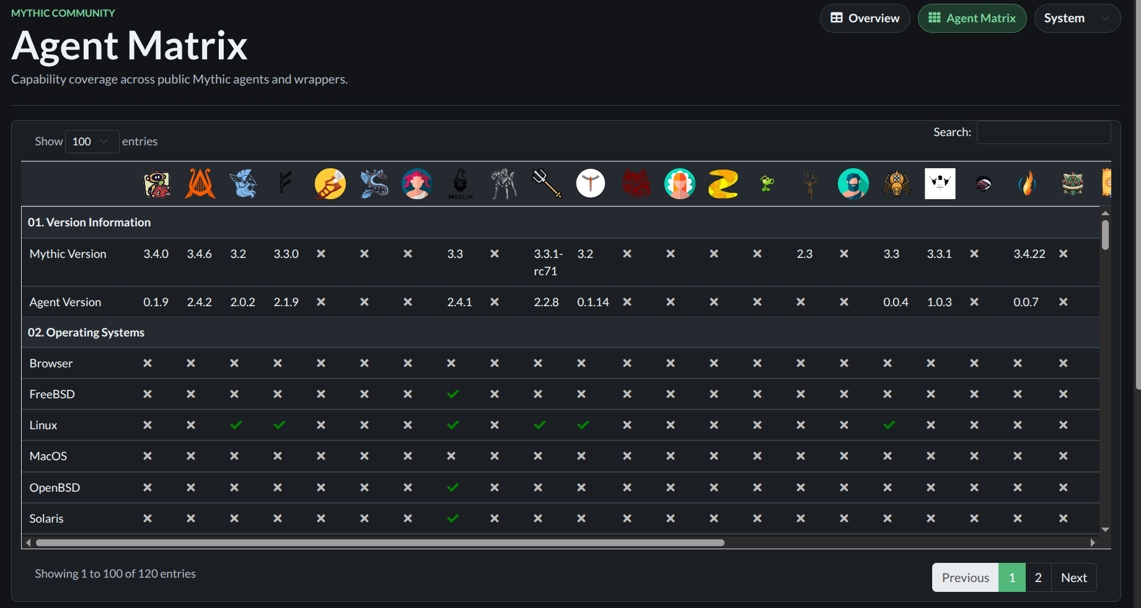
Figure 6: Mythic Agent Matrix

As shown in Figure 6, there are a lot of agents this framework develops. Scroll down and you can view details about each agent, include Supported OS, C2 profiles, Payload Output format, Architectures Supported, Features. My criteria will be choosing which Agent run on Windows, C2 profiles support http, and can run on x86_64 architecture. When narrow scope, we remain few options to choose. But I prefer Apollo because my guidance I reference using it.

Now, I will install Apollo agent to my system using mythic-cli, refer to the link at [3].
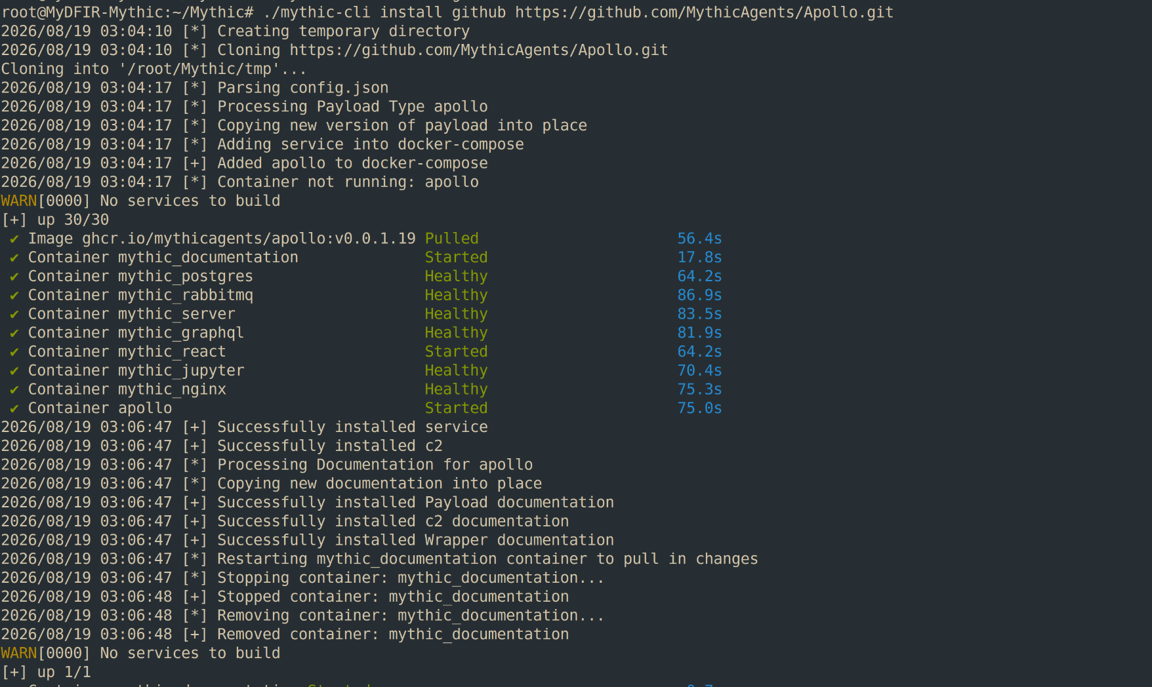
Figure 7: Install Apollo Agent
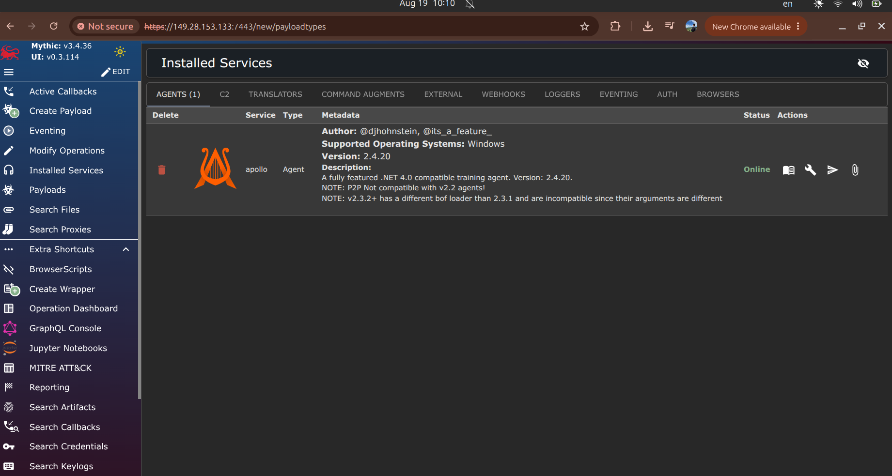
Figure 8: Installed agents tab

Next, I need to C2 profiles to determine the transportation mechanism between the C2 server and the victim running payload.
C2 Profiles are the network communication protocols that dictate how data travels between those implants (Agents) and the Mythic server. They format, encode, and encapsulate the agent's data to route it over the network securely and covertly.

I want to C2 server and the victim will communicate through http, so I will install it from this repository [4], method to install also list in README.md file from that repository [4].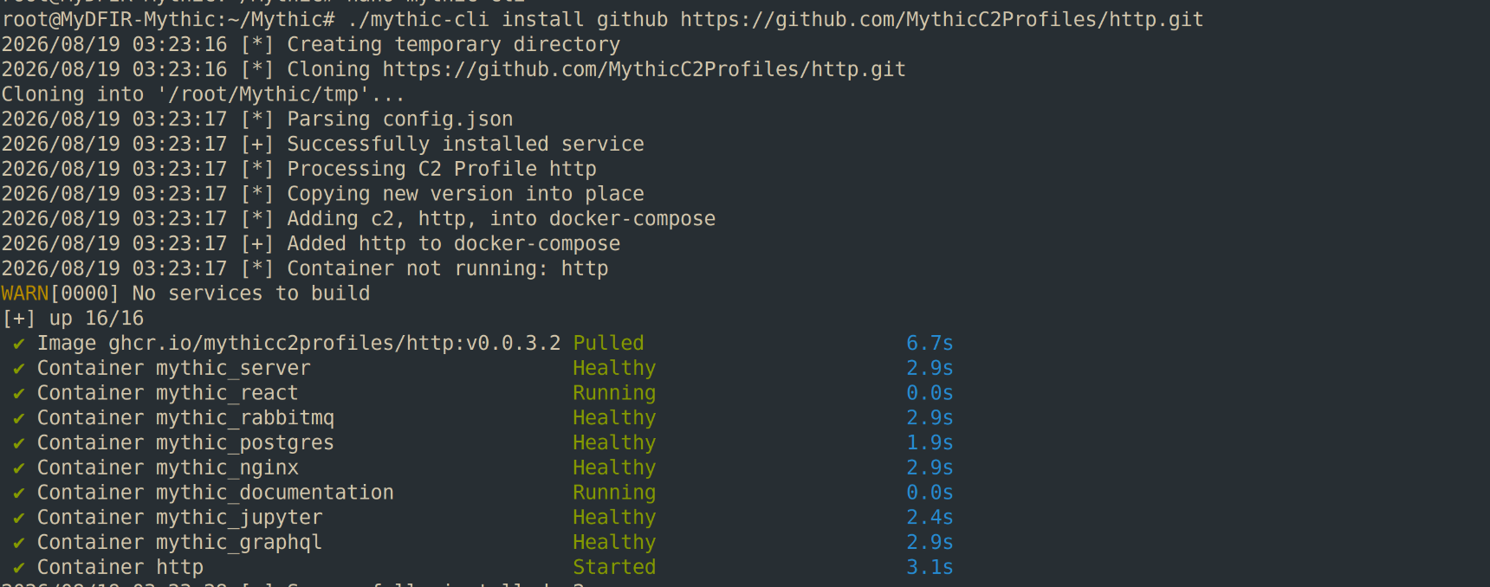
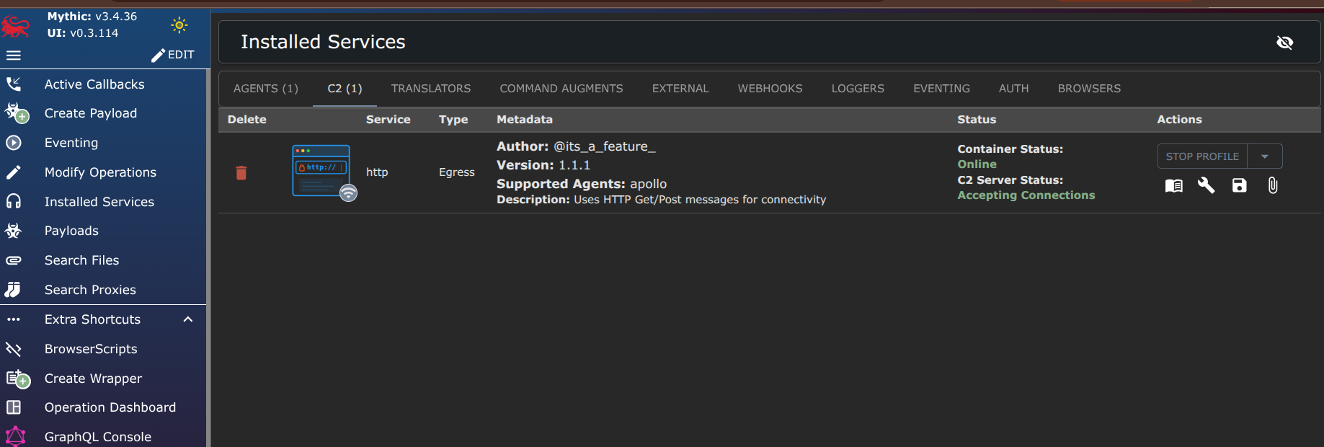
Figure 9: Installed C2 profiles

Go to tab Create Payload from the Mythic interface and followed by instructions to craft an executable file and delivery to my compromised Windows host.
Click create payload, it will bring us to “Payload Creation” page, select execution environment and file properties in dropdowns as I mentioned above:
- Operating System: Windows
- Payload Type: Apollo
- Compatible C2 profiles: http
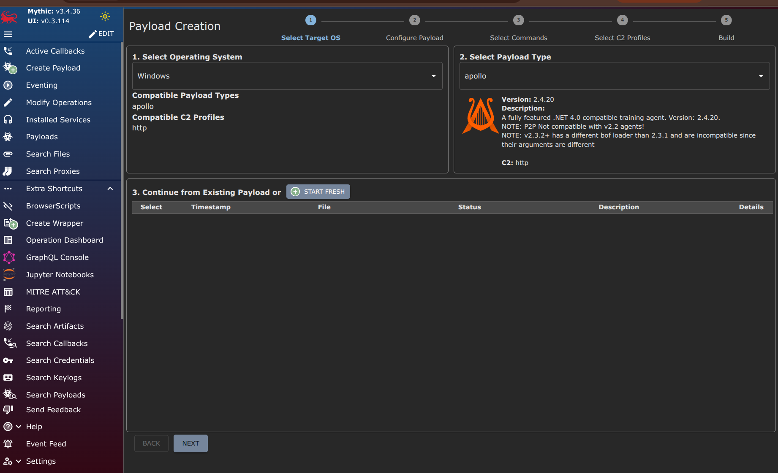
Figure 10: Payload creation
Choose output_type parameter is WinExe and keep the remaining parameters at their default values:
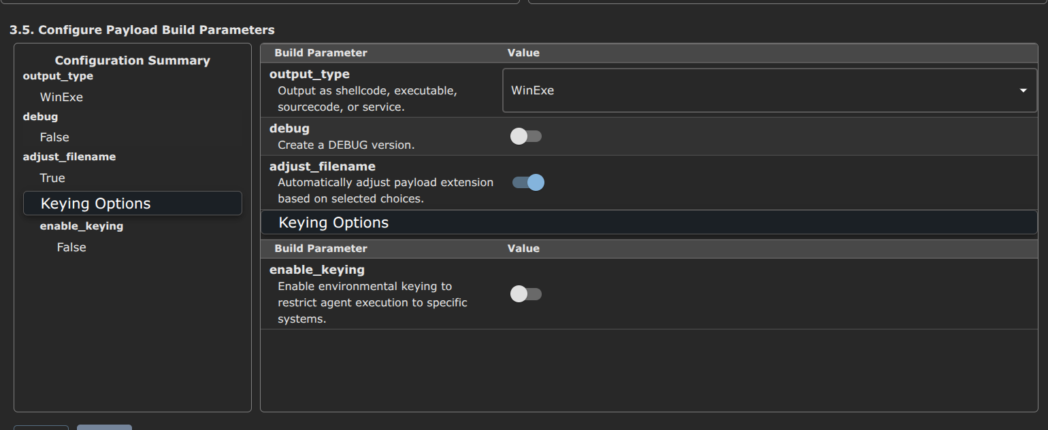
Figure 11: Payload Build Parameters configuration
In addition to selecting the configuration parameter for the payload, I also have to specify what command include to the payload:
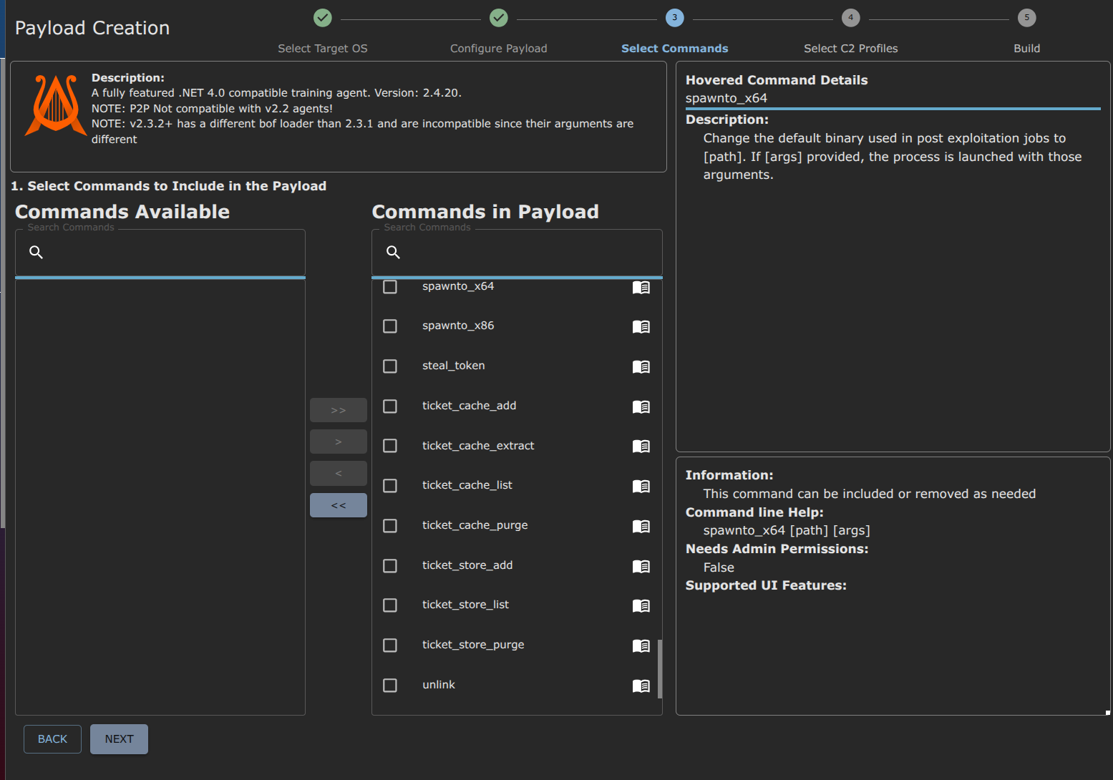
Figure 12: command selection for payload
As shown in Figure 12 above, I moved all commands in the “Commands Available” box to “Commands in Payload” box to include them in the payload. Several common commands:
- whoami: displays the current user context and privileges the agent is running under.
- ps: Lists the currently running processes on the host.
- ls/dir: lists files and directories in a specified path
- download: Retrieves a file from the target host to the Mythic server.
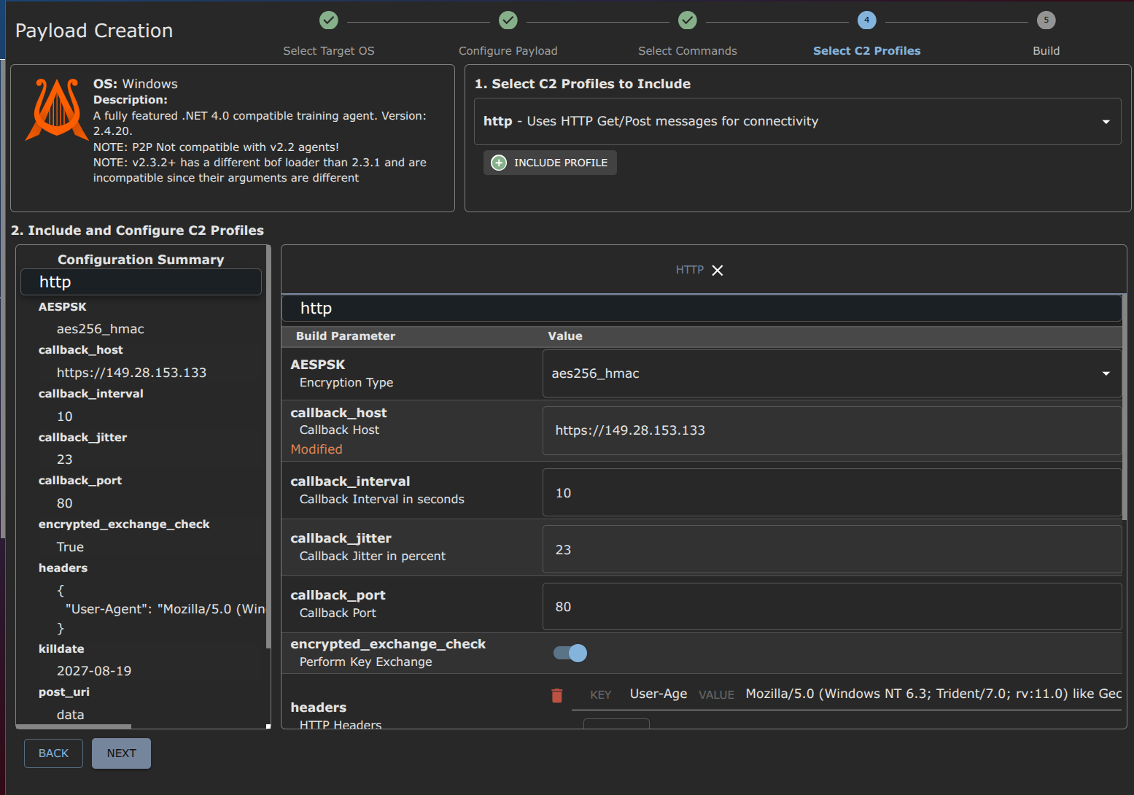
Figure 13: C2 profiles configuration
In the final step, I configured C2 profiles to specify the connection method between the C2 server and the victim machine. As shown in Figure 13, some information was set:
- Selected Profile - http: This specifies it encapsulates agent communication within standard HTTP GET and POST requests to blend in with normal web traffic.
- Encryption type - aes256_hmac: The payload’s data will be encrypted using aes256_hmac.
- callback_host - https://149.28.153.133: The agent is configured to call back to the IP address 149.28.153.133.
- callback_interval and callback_jitter: The agent is set to check in with the server every 10 seconds (interval), and to prevent defensive tools from detecting a rigid, predictable beaconing pattern, callback_jitter is applied to 23%. This means the actual check-in time will randomize by +/-23% around the 10-second mark.
- encrypted_exchange_check - enabled: allowing the agent and server to securely negotiate session keys.
- headers: A custom http header is injected to the User-Agent string, it make the agent’s network traffic masquerade as a user browsing the web using Internet Explorer 11 on Windows 8.1.
Okay, move on to Mythic server terminal and prepare something before I download it to compromised Windows:
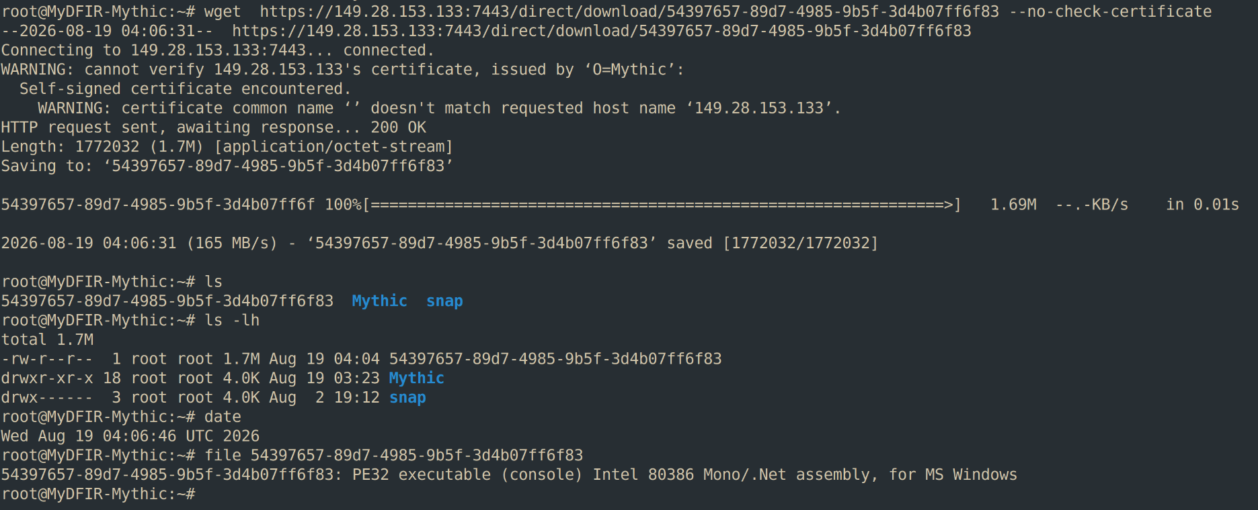
Figure 14: Pull and host the payload file on the Mythic server
In the Mythic server terminal, I prepared a directory and moved the payload into it. Then, I basically used the Python’s http.server module on port 8000 to make the payload accessible from compromised Windows.
On the compromised Windows, open powershell and use Invoke-WebRequest tool to download the payload file and specify the name of the payload that will save on disk:
Figure 15: Download the payload file
Run the file and go back to the Mythic server and see established connection notification, and now, I can control that Windows machine remotely though commands I added to the payload in the previous steps:
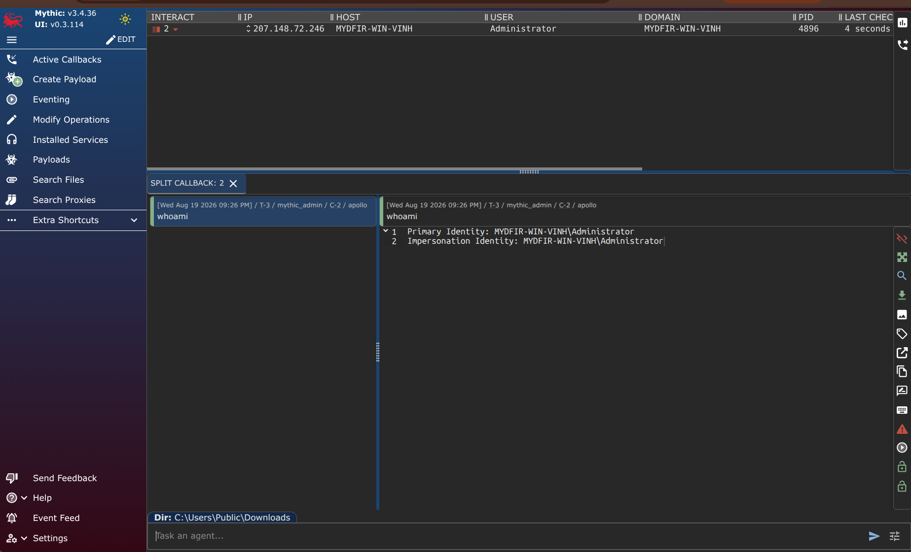
Figure 16: Established connection between the C2 server and the victim
The whoami command displayed a custom output to 2 separate lines:
- Primary Identity: This represents the base user account under which the agent’s process was launched and is currently running. It confirms the process is owned by the local Administrator account on the machine named MYDIFR-WIN-VINH.
- Impersonation Identity: In Windows, individual threads within a process can temporarily assume (impersonate) the security token of a different user - a technique frequently used in post-exploitation to access restricted files, network shares, … Because this matches the Primary Identify exactly, it indicates the current execution thread has not stolen or assumed a different user token.
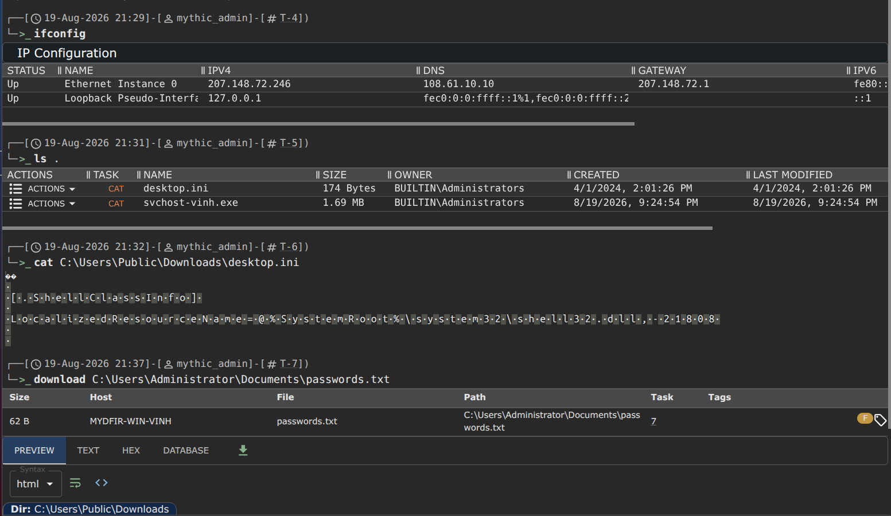
Figure 17: Discovery the machine and exfiltrate sensitive files
The attacker controls the machine through an encrypted HTTP channel and uses built-in commands on the machine. The results returned by running the commands are presented in a table with detailed columns.
The command used to display network connections information produces the same output we saw in above. I created a passwords.txt file in the Documents folder and assumed that the attacker found it and exfiltrated it to the C2 server by using the download command.
I also used other commands in this session, so Windows may have recorded these activities and sent them to the SIEM system. Let’s move on to the next day to see how I investigate.

REFERENCES:
[1] https://manpages.ubuntu.com/manpages/noble/man1/xfreerdp3.1.html
[2] https://mythicmeta.github.io/overview/agent_matrix.html
[3] https://github.com/MythicAgents/Apollo
[4] https://github.com/MythicC2Profiles/http
[5] what is .NET assembly: https://stackoverflow.com/questions/2972732/what-are-net-assemblies

